Coding Conventions

Rule 1:
All classes you create must be in the STB. The code below is a sample from 'Staff.h'. The highlighted text belows shows you how to write the namespace.
#ifndef STAFF_H
#define STAFF_H

#include <string>

namespace STB
{

//======================================================
// Base class for SmartTravel Holidays employees
//======================================================
class Staff
{
...
};

} // End of namespace STB

#endif

Rule 2:

If you are creating a new header/cpp file, place the header file into the include folder and the cpp file into the src folder.

[Step 1: Create a new header or cpp file]

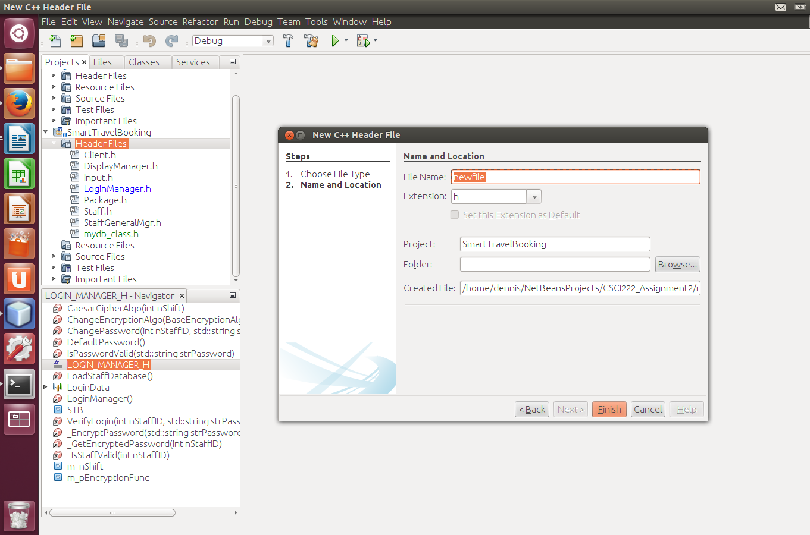
[Step 2: Click on the Browse button]

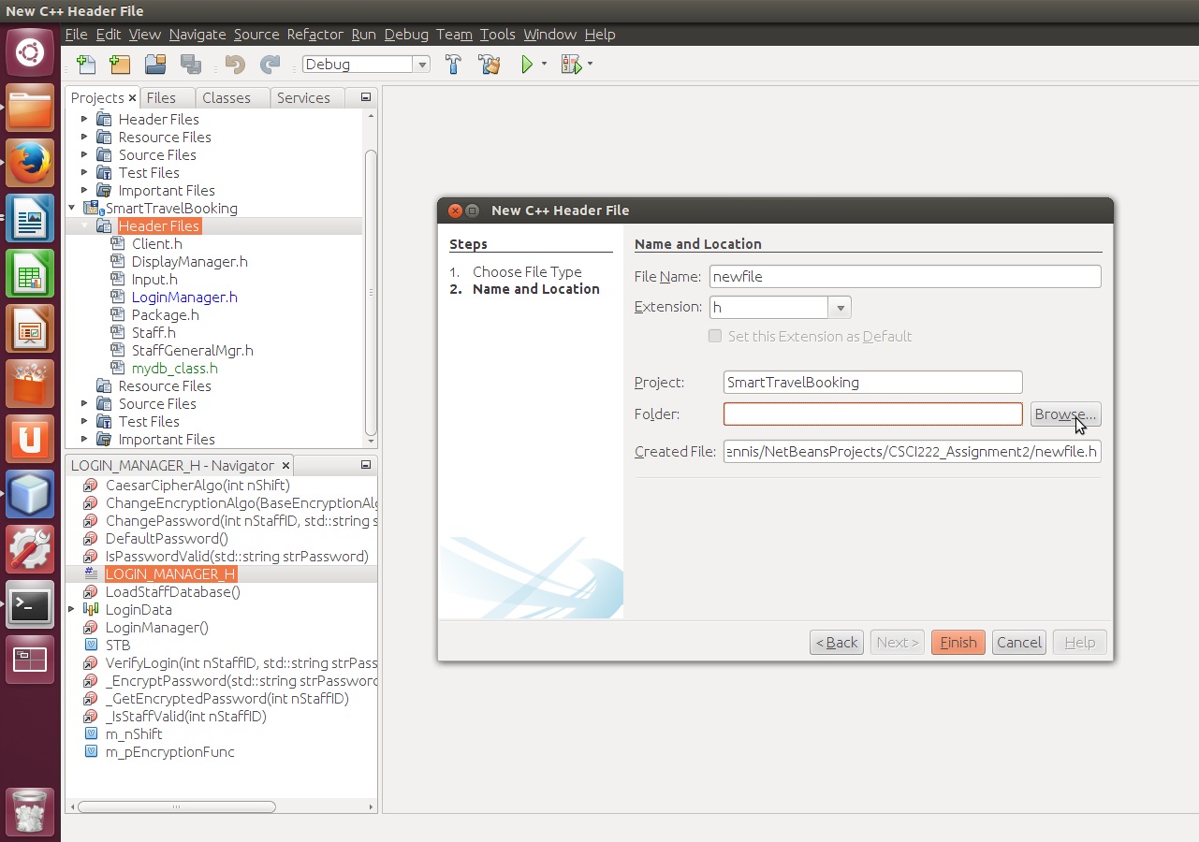

[Step 3: - select include if you are creating a header file, src if you are creating a cpp file.
- then click on Select Folder]

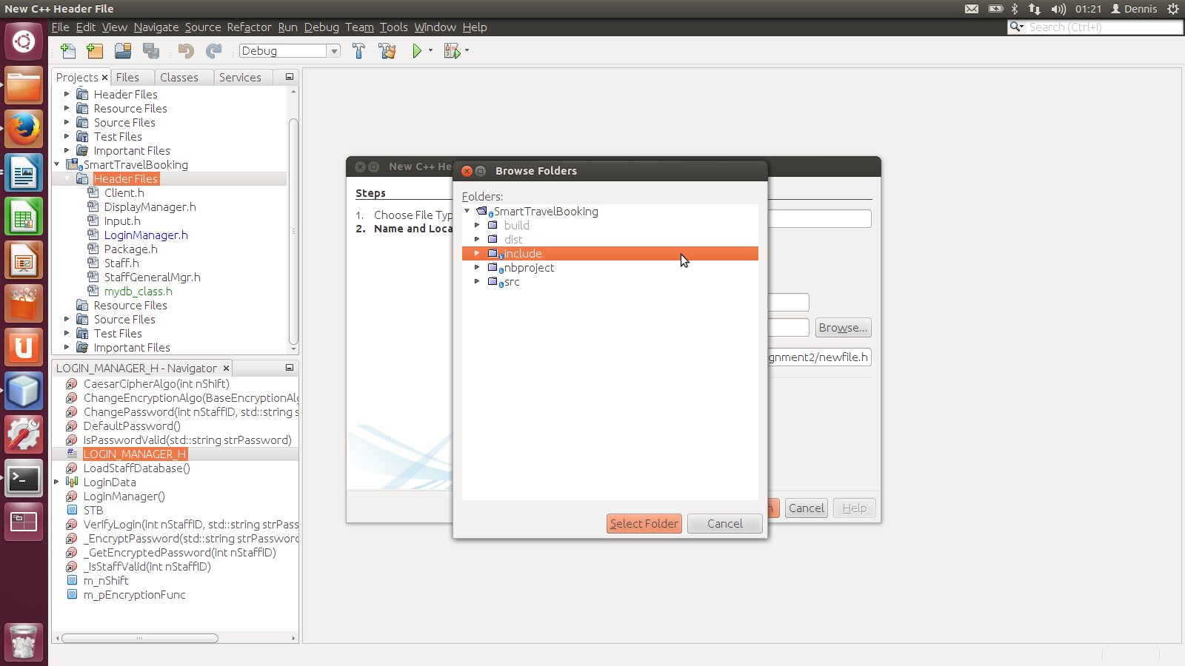
[Step 4: Click 'Finish' and you are done]

Rule 3:

All private or protected class attributes must be prefixed with m_

Example:

class Staff
{
public:
...

protected:

//================
// Data Fields
//================
int m_nStaffID; // Staff identifier
std::string m_strName; // Staff name
std::string m_strPassword; // Stores the encrypted password
eRole m_eRole;
};

